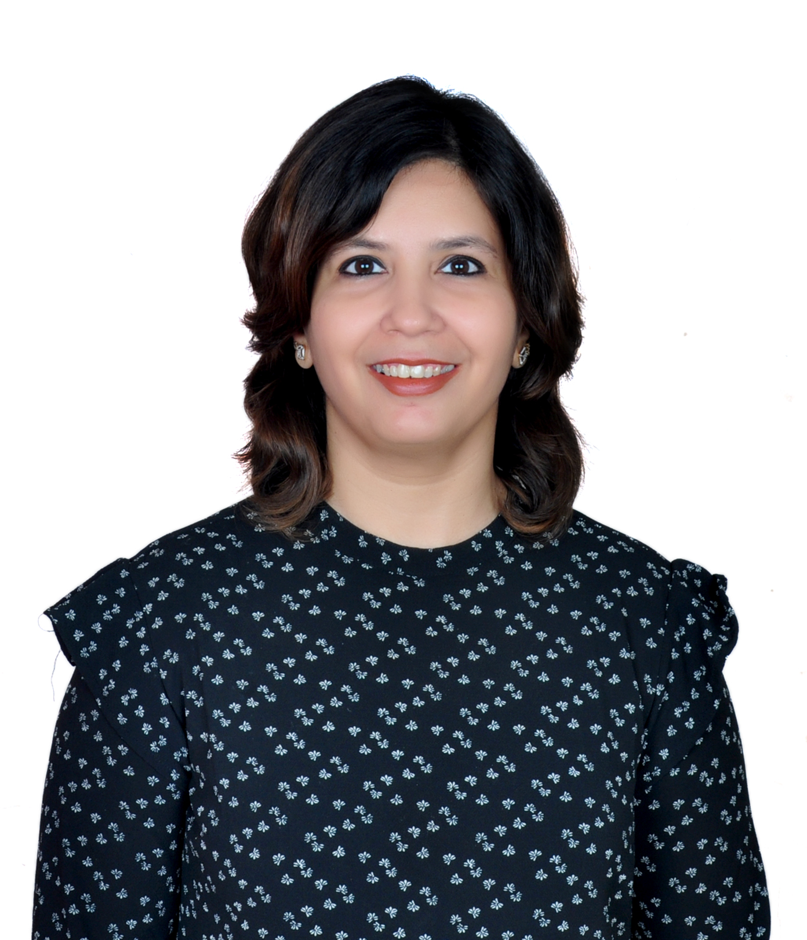

Alefiya Rangwala, Learning Consultant- Mumbai, India, Contact: +91 -98206 36730

Website: www.plaksalearning.com Facebook Page: Plaksalearning

Profile Overview:
Alefiya specializes in skill building and behavioural training programs with over 21 years of total work experience. She started her training career with Hero Mindmine, Mumbai as part of the corporate training team & also has held various middle management positions in organizations of repute like IBM, and Tata Consultancy Services, Mumbai.

A Life Coach, an MBTI certified practitioner, a certified Counsellor and as a Communication Expert she is extremely proactive and has trained more than 30,000+ people and has docked 18,000+ hours in training. She has 4 international certifications to her credit and has successfully trained audiences across India and Dubai.
As a trainer, she has been recognized for creating stimulating and interactive learning environments, encouraging participation and individual contributions, and providing effective, clear, and concise information in formats that promote high retention levels.
A Reiki master and a teacher she is associated with Mahavatar Babaji Tad Ekam Foundation– a spiritual charitable group, teaching the universal healing method of Reiki and different forms of healing Meditations and Kriyas.

Education:
- Bachelor of Science
- Post Graduate Diploma in Medical Lab Technology

Certifications:
- Certified Life Coach from Academy of Modern Applied Psychology
- Certified MBTI Practitioner from Anahat
- Certified Professional Behavioural Analyst (CPBA)- DISC
- Certified Trainer – ICTS, City and Guilds, UK
- Global Career Counsellor, UCLA & Univariety -Singapore
- Certified Counsellor- Heart to Heart Institute, Mumbai
- Certified BEI (Behavioural Event Interview) trainer from TCS

Program Offerings:
People Management  - First Time Manager  - Young Leaders Program  - Coaching and Feedback  - Effective Decision Making  - Creativity and Innovation  - Effective Delegation  - Effective Feedback Skills  - Effective Change Management  - Skilful Selection  - Creating Winning Teams  - Managing High Performance Teams  - Ownership and Accountability  - Performance Management | Self-Management  - Emotional Intelligence  - Enhancing Personal Effectiveness  - Effective Time Management Skills  - Business Etiquette and Grooming  - High Impact Presentation Skills  - Rewire Your Thinking  - Handling and Coping with Change
Wellness Programs  - Living a Stress-Free life  - Women- Centred programs  - Meditation and Relaxation Sessions | Language and Culture  - English Language Lab  - Accent Neutralization  - Cross-Culture Sensitization
Communication  - Business Communication  - Persuasion and Influencing Skills  - High Stakes Conversation  - Assertive Skills  - Email Etiquette | Managing Customers  - Customer Servicing  - Achieving Customer Excellence

Levels of Experience:
Junior, Middle, Senior Management

Industry/Functional Experience:
- Banking and Financial Services
- Engineering & Manufacturing
- Pharmaceuticals and Health Care
- Media and Entertainment
- Logistics
- Telecommunication
- Information Technology (IT)
- BPO & KPO
- Retail
- Automobiles

Representative Clients:
Media and Entertainment
- Viacom 18 Network (Colors, Etv)

Health Care
- Narayana Health Hospitals
- Columbia Asia Hospital

Information Technology (IT)
- IBM
- Tata Consultancy Services
- Ingram Micro Ltd
- Aditya Imaging- Aira
- Godrej Infotech
- National Stock Exchange (NSE)
- Cross-Tab Services
- QAD India
- Cap Gemini
- FSS
- Mphasis-HP
- Aptech Ltd
- Tata Technologies

KPO
- Tresvista

Logistics
- XPO Logistics

Telecommunications
- Tata Communications Ltd
- Orange

Automobiles
- Mahindra & Mahindra Automotive

Retail
- Raymonds Ltd.

Education
- Anglo Eastern Maritime Academy
- Center for Management
- Orissa Engineering college

Others
- GVK MIAL (Mumbai International Airport limited)

Banking and Financial Services
- Emirates NBD (Dubai)
- Bajaj Finserve
- Axis Bank
- RBL Bank
- Kotak Bank & Securities
- HDFC Bank
- Royal Bank of Scotland (RBS)
- JP Morgan
- Central Bank of India
- Bharat co-op bank ltd.
- Deloitte Ltd
- L&T Finance
- Reliance Mutual Funds
- Cholamandalam MS
- Jardine Lloyd (JLT)
- Anand Rathi

Manufacturing and Engineering
- Godrej & Boyce
- Arvind Mills
- Adani Ports
- Weatherford Drilling
- JK Files -Raymonds
- Essel Propack
- Aditya Birla Group
- Essar Ltd
- Atlas Copco India Ltd.
- Tata Power
- UB Group
- General Mills
- Siemens ltd
- Nocil India
- Toyo Engineering
- Advanced Enzyme
- Honeywell Automation
- Anglo Eastern Shipping

Pharmaceuticals
- Cipla Ltd
- Lupin Ltd
- Sun Pharma Ltd
- GlaxoSmithKline Ltd
- Novartis (Animal Health)

Beauty and Salons
- BBlunt Salons

Realty
- Lodha Group
- Raymond Realty

