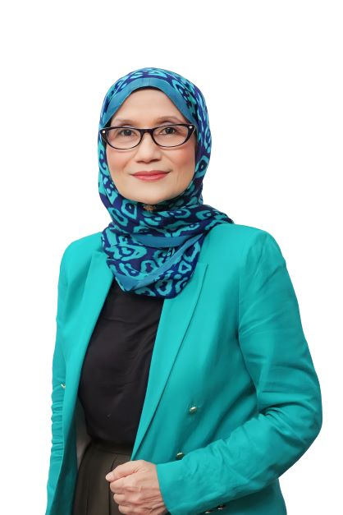

RESUME

Objective

Seeking opportunities to impact personal and professional development of others by leveraging from vast experience as international corporate trainer, Human Resource (HR) practitioner, guest project lead in customer experience and organizational development, and people leader.

Personal Background

Name: Alwiyah Ismail
Telephone: 012-989-0199
Email: alwiyahismail64@gmail.com

Academic and Professional Qualifications

- Certified Trainer by Human Resource Development Corp (HRDC) -2023
- Certificate in Training & Development – 1993
- Hay Methodology of Job Evaluation – 2016
- Diploma in Teaching English as Second Language (TESOL) – (In progress)
- Bachelor of Science Degree (Botany), University Malaya – 1986

Career and Employment Summary

American Express (M) Sdn Bhd. (1986-1996) – Customer Service Associate, Executive in Training & Development

- As Customer Service Associate, provided customer service and resolved customer situations to achieve excellent customer experience.
- As Executive in Training Development, planned and implemented annual training plans in soft skills, leadership and competency development.

American Express (M) Sdn Bhd. (1997-2004) – Learning & Development Representative for ASEAN & Pakistan

- Worked in a virtual team of five (5) members located across the Japan/Asia Pacific (J/APA) region, reporting to the Regional Manager of Learning & Development J/APA.
- Implemented the global training curriculum for four (4) ASEAN markets (Malaysia, Singapore, Indonesia, Thailand & Pakistan).
- As a liaison to the HR Heads of ASEAN markets, supported the global and regional learning interventions and employee development initiatives.
- Collaborated with market HR Heads in the implementation of other development initiatives, including the Learning Management Systems, Centers of Excellence, HR Shared Services and Change Management.

Prince Court Medical Centre Sdn Bhd (2006-2017):

- Manager, Performance & Change Management (August-December 2017)
- Manager, Learning & Development (2014-August 2017)
- HRD Specialist (April 2006 -2014)

- Pioneered the hospital set-up, reported to the HR Director and led a team of three (3) direct reports.
- Established Human Resource policies, standard operating processes and systems, focusing on the following core functionalities:

  - On-boarding & probation, training & learning development, employee performance management, consequence management, education sponsorship, and internship.
- Supported implementation of employee engagement, change management and transformation initiatives towards business performance.
- Collaboration with line managers in achieving HR standards for hospital accreditations.
- Supported HR peer managers with their core functions in recruitment, remuneration, industrial relations, and talent management.

Major Accomplishments

- 2006-2017 - Established HR policies, standard operating procedures and systems during the hospital set-up till its full operations; towards achieving HR standards in the hospital accreditation under Malaysian Society for Quality in Health and Joint Commission International.
- 2017 – Led team to win the HR Award organized by Pembangunan Sumber Manusia Berhad
- 2014-15 – In the capacity of Project Manager of cross functional teams, led team to achieve an increase in the annual customer satisfaction indicator, from which the organization became a benchmark for several other organizations in creating positive guest experience.
- 2010 – Led team to win the 2010 Asian Hospital Management Award for the Performance Management Systems.

Training Certification & Experience

Fully accredited to conduct the following franchise training:

- Interaction Management by Direct Dimension International (DDI)
- Targeted Selection Competency-based Interviewing by DDI
- Frontline Leadership by Zenger Miller
- Leadership Series by Zenger Miller
- Achieving Extraordinary Customer Relations Skills by Kaset International
- Business As Unusual (Change Management) by Pritchett -Raumler Brache
- DiSC Profiling by Thomas International Systems

Fully accredited by American Express (AMEX) International Inc. to conduct the following programs for AMEX employees (Associates and Executives) in ASEAN region.

- American Express Quality Leadership
- AMEX Situational Leadership (Ken Blanchard) for Managers and Individual Contributors
- Communicating Feedback using AMEX model for communicating feedback
- Driving High Performance (based on the book ‘Break All the Rules’ by Marcus Buckingham and Curt Coffman)
- ‘Building on Your Abilities’ on career development based on Career International Systems, Inc.
- Selecting for Success

Conducted the above programs between late 1990’s through 2004 for AMEX employees in Malaysia, Singapore, Indonesia, Indonesia and Pakistan from diverse cultural and learner profiles.

Trainer Profile - Alwiyah Ismail

Alwiyah had a thriving 11 years in healthcare; as a self-starter in the
hospital set-up, commissioning, and hospital accreditation. In her capacities as HR Practitioner, Project Lead and People Leader, she was accountable for a wide array of organizational initiatives in Human Resource Development (HRD), customer experience, people development, and organizational culture transformation. Her 15 years of experience with an international travel & financial services organization accelerated her career growth from a customer service specialist role into the market learning & development representative for the A.S.E.A.N markets. In this role, Alwiyah was the liaison for the market HR Heads in cascading and implementing the HR global solutions. Being internationally accredited to train the global curriculum for these markets, Alwiyah trained employees from diverse cultural and learner profiles in people and career development, customer experience, change management and HR processes skills.

She established HR processes especially on-boarding, probation, learning & development, performance management systems, consequence management, education sponsorship and internship towards achieving the local and international healthcare accreditation. Her engagement in organizational development initiatives especially in Guest Experience and work culture transformation, in project or HR roles, helped the organization earned awards in the medical tourism industry, Asian Hospital Management Awards (Human Resources) and HR Award by Human Resource Development Corporation.

As an accomplished in-house Trainer/Facilitator, Alwiyah leverages her experiences as People Leader and HR Practitioner; especially in Training and Career Development, Performance Management, and Guest Experience to engage and enable others to unleash their potentials and achieve their performance and career goals. One usually describes her as enthusiastic, motivating, versatile, animated, adaptable to diverse culture and learner profiles.

Alwiyah holds a Bachelor of Science Degree (Botany) from University Malaya, Kuala Lumpur, is a Certified Trainer under Human Resource Development Corporation, Certified Practitioner of DISC Profiling and Job Evaluation - Hay Methodology. She is also accredited to conduct international franchise programs in Customer Service and interpersonal skills, Situational Leadership, Behavioral Interviewing Skills, Change Management.

