CURRICULUM VITAE
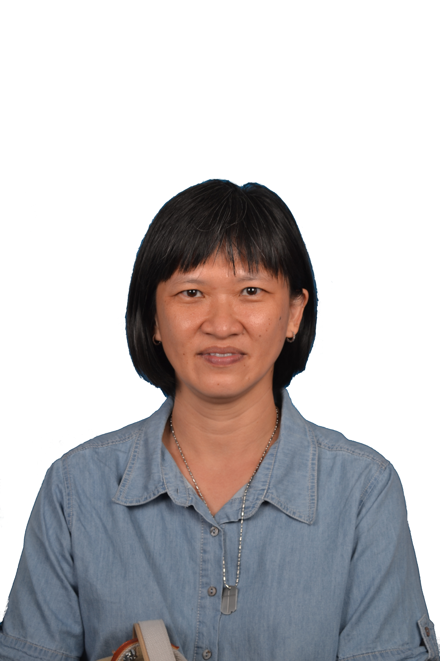

LILIAN LAM HOOI MING

17, DC 3/19,
Desa Coalfields, Sg Buloh,
47000, Selangor, West Malaysia
H/phone : +6 016 2215 888

PERSONAL PARTICULARS

Citizenship : Malaysian
I/C Number : 660801-02-5026
Gender : Female
Date of birth : 1st Aug 1966
Age : 55+
Marital Status : Single
Email address : lionlamb18@yahoo.com
Highest Education Obtained : Masters Degree in Information Technology, CCNA.
Teacher’s permit from MOE : (Permit number PM/IPTS/2019/04/2119).
For teaching degree level Computer Science
Professional Certifications : Certified ACTA Trainer (Singapore)
: VTO (Vocational Training Officer) (JPK Malaysia)
Training Scope : Professional trainer in this fields :
IP Network/Protocols :
Ethernet frame, TCP/IP protocol,
Network Troubleshooting.
Routing Protocols (OSPF, RIP, BGP), Ipv6, CCNA (Cisco Certified Network Associate- Routing and Switching).
: Part Time lecturing in University College and College in Computer Networking

WORK EXPERIENCE

Company | Designation | From | To | Duration
Own | Freelance Technical Trainer | Dec 2016 | present
Webe Sdn Bhd (formerly known as Packet One Networks) | Senior Principal/Manager | April 2016 | Nov 2016 | 7 months
Packet One Networks (M) Sdn Bhd | Manager | Apr 2015 | April 2016 | 1 year
Orbitage Sdn Bhd | Technical Trainer | Feb 2009 | Mar 2015 | 6 years
Packet One Networks (M) Sdn Bhd | Senior Operations Executive (part time) | Dec 2007 | Feb 2009 | 13 months
Kolej Tunku Abdul Rahman | Lecturer (full time) | 2000 | 2006 | 5 years
Hewlett Packard Malaysia Sdn Bhd | Process Engineer  Senior Process Engineer  Senior Product Engineer | 1990  1994  1996 | 1994  1996  1999 | 9 years

PART TIME EXPERIENCE

Company | Designation | From | To | Duration
TAR Universiti College | Part Time Lecturer | 2014 | present
New Era Vocational College | Part Time Vocational Training Officer | 2019 | present
YPC International College | Part Time Lecturer | 2019 | present
El Shaddai E Learning Centre | IGSCE ICT teacher | 2018 | 2018 | 1 term
VIP Education | Part Time Home Tutor | 2013 | 2015 | 2 years
Institute Perkim Goon | Part Time Lecturer | 1996 | 2001 | 4 years
Informatics Taiping | Part Time Lecturer | 1999 | 2000 | 4 months
Systematic Penang | Part Time Lecturer | 1999 | 2000 | 3 months
Han Chiang College Penang | Part Time Lecturer | 1999 | 2001 | 2 years
Magnificent Freedom | NCC Examiner | 2004 | 2018 | Contractual(by project)

WORK RESPONSIBILITIES

Dec 2016 to present : Freelance Trainer/Part Time Lecturer
- Deliver courses,
- Conducting assessment
- Developing materials for lecture, tutorial and practical
- Setting written and practical tests/exams

April 2015 to Nov 2016 : Manager/Senior Principal Webe (previously known as Packet One Networks Sdn Bhd

- Manage the business process to support the LTE launch. This includes analyzing process gaps, competency gaps, business process development and improvement.

Feb 2009 to Mac 2015: Technical Trainer at Orbitage Sdn Bhd (www.orbitage.com)

- Conduct training to Managers, Engineers, Technicians of Telecommunications Company in Malaysia , and Singapore on Internet Protocols. Clients include
  - CELCOM
  - DIGI
  - MAXIS
  - TELEKOM MALAYSIA
  - PACKET ONE
  - Universities (UTeM, UniSza, UiTM,)
  - Polytechnic (PTSS Arau)
  - Hewlett Packard
  - Astro
  - Singtel (Singapore)
- Develop and deliver training programmes.
- Syllabus includes: Introduction to Internet Protocol, Ethernet Protocols, Routing Protocols (Routing Information Protocol, OSPF, BGP), IPV6, Multiprotocol Label Switching, Introduction to LTE, QoS and Traffic Engineering
- Review and updating of training and presentation materials.
- Training in NOSS Certified Courses for Telecommunications Personnel
  - Certified IP Associate (CIPA)
  - Certified IP Engineer (CIPE)
- Deliver Internet Protocol courses under Prestariang (Project 3PP) to universities and politechnics. So far, I have covered UteM, UiTM, Unisza, PTSS (Politeknik Tunku Syed Sirajuddin).
- Currently involved in developing the IT track courses : Java programming and Linux Operating System.

Dec 2007 to Feb 2009 Senior Operations Executive in Packet One Networks (M) Sdn Bhd.
- Create, implement, control and maintain the information flow for operational data and information.
- Document controller, up keeping of document nomenclature, creation, distribution.
- Audit departments in the scope of process flows and customer’s satisfaction.
- Conduct training across company in relation to QMS processes.
- Coordinate training, scheduling for trainers and employees, support Human Resource in training and development.
- Clarifies requests for enhancements or systems changes with the requestor and documents project definition.
- Access rights setting for Enterprise Knowledge Portal, and back up servers.
- Software used Microsoft Visio, Adobe Acrobat Professional, Microsoft Office: Word, Excel, Powerpoint.
- Assist in training and coordinating technical training for employees.

1996 to 2006 Lecturer :

2007 onwards : Part Time/ Free-lance
2000-2006 : Full Time at TARC
1996 to 2000 : Part time

- Lecturing and handling coursework for Certificate, Diploma and Higher Diploma students.
- Supervise projects for final year Certificate and Diploma students.
- Responsible for feedback and restructuring of subject syllabus and lecture/lab hours for IT courses.
- Written subject notes, creating tutorial questions, and responsible for setting assignments, Mid Term and final exam questions.
- Student counselling on courses and study issues.

Subjects Taught

- Computer Networks (Tunku Abdul Rahman University College)
- Advanced Computer Networks (Tunku Abdul Rahman University College)
- Fundamentals of Computer Networks (Tunku Abdul Rahman University College)
- Introduction to Computer Networks (Tunku Abdul Rahman University College)
- Internet and Web Technologies (YPC International College)
- Computer Networks (New Era College)
- Network Security, Monitoring and Management (New Era College)
- Certified IP Associate (Orbitage Sdn Bhd)
- Certified IP Engineer (Orbitage Sdn Bhd)
- IPv6 (Orbitage Sdn Bhd)
- Applied Network Security (Orbitage Sdn Bhd)
- NCC Modelling for Computing Using Mathematics (Diploma) (Instituted Perkim Goon)
- NCC Network Environment(Advanced Diploma) (Institute Perkim Goon)
- IMIS Network (Higher Diploma) (Institute Perkim Goon)
- IMIS Database Design (Graduate Diploma) (Institute Perkim Goon)
- ASHDS Systematic Networking (Diploma) (Systematic College)
- Network (Informatics Diploma) (Informatics College)
- Multimedia Design (Diploma) (theory part) (Han Chiang College)
- Webpage Design (Diploma) (Informatics College)
- Microsoft Word (Informatics College)
- Introduction To C Programming (Kolej Tunku Abdul Rahman)
- Data Structures and Algorithms Using C (Kolej Tunku Abdul Rahman)
- Advanced Data Structures and Algorithms Using C (Kolej Tunku Abdul Rahman)
- Introduction to Java Programming (Kolej Tunku Abdul Rahman)
- Windows Programming (Visual Basic) (Kolej Tunku Abdul Rahman)
- Electronic Commerce (Kolej Tunku Abdul Rahman)
- Data Communications and Network (Kolej Tunku Abdul Rahman)

NCC examiner :
Part time examiner for the subject ENTERPRISE NETWORKING (Diploma Level) for NCC Asia Pacific region.

Engineer(Hewlett Packard) :

Hewlett Packard Manufacturing (now Agilent Technologies) is a semiconductor manufacturing company. The department I worked in produces LED (light emitting diode) lamps.

1996-1999 Senior Product Engineer

- Helped pioneer the Product Engineering department. We expanded the department from 2 engineers to a total of 7 engineers.
  - Responsible to transfer Product Engineering department from US and Germany to Penang during the downsizing exercise in the States and Europe.
  - Assist my manager in hiring, interviewing new engineers. Training and mentoring the new engineers to take over projects that were transferred from US to Penang.
- Responsible for Special Customer Requests (customized products). Produces samples(prototypes) for customers
  - Implement the manufacturing of customized product into the production line. Liase with Sales and Marketing department, QA and Production to make sure product is manufactured per customer’s requirement.
  - Responsible for auditing Production Lines and making sure products are manufactured according to the specifications.
- Customer visits (to Japan, New Zealand, Texas) to initiate technical response from customers on products and also if any quality /shipment problems encountered.
- Work with Sales and Marketing department (San Jose, Japan, Germany, Singapore) and coordinate with Production lines (Penang) to ensure timely delivery of special shipments to Tier 1 Automotive customers.

1994 – 1996 Senior Process Engineer

- Responsible to ensure successful implementation of new production line from US to Penang.
- In charge of setting up production line for semiconductor products and implementing line quality assurance through statistical quality control and documentations.
- Liase with Automation and Tooling department for machine modifications and improvements.

- In charge of Capital and Tooling budget (RM 1.2mil) to ensure projects implemented and payments are on schedule. Liase with all parties if any project is delayed and coordinate department approved expenditure to make sure spending is on target.
- Act as a coordinator for BS ISO 9000. Implemented ISO 9000 requirement into the production line. Represent product line during ISO external audit and entertain external auditors for the production line.

1990 – 1994 Process Engineer

- In charge of maintaining yield of production line and of product quality.
- Troubleshoot production /machine problems.
- Implement quality controls in the manufacturing line through Statistical Quality Controls.
- Liase with Customer Service Department to solve customer’s product quality issues.
- Liase with Production Section to solve yield and shipment problems.
- Work with Die/Wafer Fabrication Department to select wafers to increase production yield.
- Process improvements : implemented new designs and modifications to products, process , tooling and machines to generate a better product with higher yields.
- Awarded ‘THE CEO CUSTOMER SATISFACTION AWARD’ from the CEO , Lew Platt in appreciation of my commitment to customer satisfaction. (presented a project POLYLED LEAD FRAME MODIFICATION on product improvement – to solve process (gang saw) problem)
- Knowledge of semiconductor processes such as Die attach, Wire Bonding, Epoxy Casting, Transfer Molding, Testing, Sawing and Tape and Reel.

OTHERS

INDUSTRIAL TRAINING EXPERIENCE

Company | Nature of Company | Project | Duration
Honda Car Assemblers  Johor Bahru | Assembly of Honda Cars | Design Spray painting booth | 7 weeks  (1986)
Hong Leong Lurssen Shipyard  Butterworth | Ship/Boat maintenance | Maintenance of generators, shafts | 7 weeks  (1987)
Thong Guan Plastics Sdn Bhd  Sg Petani | Manufacturer of  - polypropylene, polyethene and High density poly propylene plastic bags.  - nylon string | Maintenance of film blowing, extrusion machine, string winding machine | 7 weeks  (1989)

ACADEMIC QUALIFICATIONS

University Education

University | Year Attended | Qualifications Obtained
University Science Malaysia | 1997 – 2001 | Masters of Science in Information Technology
University Technology Malaysia | 1985 – 1990 | Bachelor of Science in Mechanical Engineering (First Class honours) .  Won the Pelajar Terbaik (top student) award.

Professional Qualifications

College | Year Attended | Qualifications Obtained
IAL (Institute of Adult Learning Singapore) | 2018-2019 | ACTA (Advanced Certificate in Training and Assessment)
Cisco Networking | 2014 | CCNA, Cisco Certified Network Associate Routing and Switching (cert no : 417494175871HOXN)
Bible College Malaysia | 2014 | Diploma in Counselling Studies
Bible College Malaysia | 2010 – Dec 2017 | Bachelor of Theology
Informatics | 1997 | Advanced Certificate in Computer Systems Support

Primary/Secondary Education

School | Year Attended | Qualifications Obtained
Father Barre’s Convent Primary School,  Sg Petani, Kedah | 1972 – 1978 | -NIL -
Father Barre’s Convent Secondary School, Sg Petani, Kedah | 1979 – 1983 | Sijil Pelajaran Malaysia Grade A (Top Student Award)  General Certificate of Education (1119 English)
Ibrahim Secondary School,  Sg Petani, Kedah | 1984 – 1985 | -NIL- (left for university)

Awards Received

Award | Year | Given By
SPM Top Student award | 1983 | Sekolah Menengah Father Barre’s Convent
Best Student Mechanical Engineering Session 1989/1990 | 1990 | University Teknologi Malaysia

Extra Curricular Activities

Activities/Club/Society | Year | Position
Girl Guides | 1979 - 1983 | Assistant Girl Guide Leader  Group Leader
Choir | 1981-1982 | Alto Group, represent school and state 1982
Class | 1982-1983 | Assistant Monitor
Science Society | 1984 | President
Electronic Club | 1984 | Committee Member
Chinese Language Club | 1984 | member
Girl’s Welfare Society | 1984 | member
Mathematics Club | 1984 | member
Tae Kwon Do Club | 1985-1990 | Committee  Participated in Contest  Sparring (Won Silver Medal)  Pattern Green Belt (Silver Medal)
English Language Week | 1987 | Participated in Debate, Essay Writing Competition

Other Education, Courses Attended

Courses /Certificate | Company | Year | Level
ACTA Singapore (Advanced Certified Training and Assessment) | IAL Singapore (Institute of Adult Learning Singapore) | 2019 | Advanced Certificate
4DX | Packet One Networks | 2015 | Attendance
Training the Trainer | MIM | 2009 | Certificate of Attendance
Java programming | Computer Systems Advisers Berhad | 2005 | Certificate of Attendance
Evaluation of Teaching/Lecturing | TARC | 2001 | Certificate of Attendance
Yamaha Electone Performance | Yamaha | 1979 | Grade 10 ELECTONE
Tooling/Toolshop Equipments and Capabilities | Desenco | 1991 | Certificate of Attendance
Management Problem Solving and Decision Making | Kepner Tregoe | 1991 | Certificate of Attendance
Safety Seminar on Swagelok tube fitting | Swagelok | 1992 | Certificate of Attendance
Japanese Language – Basic | Intec College | 1992 | Certificate of Attendance
Financial Management | Malaysian Institute of Management | 1992 | Certificate of Attendance
In House training on Basic Radiation Protection for Supervisor/Radiation Protection Officer | Nuclear Consultancy and Services | 1995 | Certificate of Attendance
Music Synthesis Level Examination | Digital Music Systems | 1996 | Level 1
The Associated Board of The Royal Schools of Music | ABRSM | 1997 | Grade 5 PIANO
The Advanced Certificate in Computer Systems Support | Informatics | 1997 | Grade : Distinction

