Haarrdika Rajdev

Nature is always kind. We are born to Smile, Shine and Succeed.
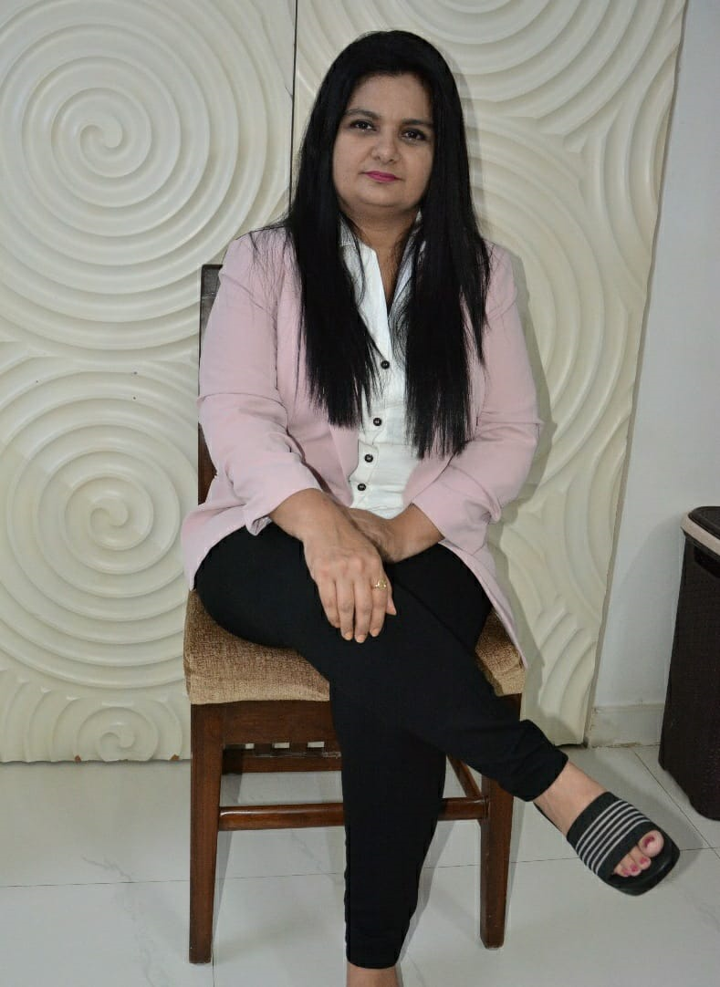

Hi, I am Haarrdika Rajdev,
Founder of Sofweb Consultancy – Initiate Involve Evolve!

I am on a mission to *ignite the spark within and transform*
1 million lives by 2025.

In my journey, I have earned expertise and experience as a

- NLP Master Practitioner
- Soft Skill Expert
- Leadership Coach
- Genetic Brain Profiling Consultant
- Career growth Enhancer
- POSH | POSCO ENABLER

I'm happy to *help everybody* who wants to *reframe their lives and experience their diamond destiny in reality*.

If you are interested to experience the journey of mindful transformation to stir the pioneers within you and unlock your potential to live to the fullest *then* allow me to commend this cycle of learning and growing to unleash your qualities *that enables you to* lead a spectacular living both personally and professionally.

I utilize my strengths of being a fantastic communicator, empathetic being, compassionate mother with a positive attitude to mentor people to 'Evolve'.

Connect with me to create and experience *an enriched and Empowered living*

*Together we can bring wonders in your Life*

Qualification:

- A graduate in Commerce from Stella Maris College, Chennai
- Diploma in Multimedia, IMAGE, Chennai
- GNIIT, NIIT , Chennai
- Diploma in Technical Writing, KBuffer, Chennai
- MCA, IGNOU, Distance Learning
- Diploma in Advanced Training for Soft Skills from The American TESOL Institute
- ICP-ACC Certified Agile Coach,
- Iron Lady Leadership Coach Certification,
- NLP Master Practitioner, SK Consultancy, ABNLP
- Genetic Brain Profiling Consultant, MIDNA
- Pressuring my NLP Trainer Certification with Treacle Academy, UK
- Associate Partner, of the National Institute of Skills Training, NIST,
MSME, ISO 9001-2015 ,QCI, IAF
- Regional Director, of International Association of Soft skills Trainers, Bestow Edutrex International.

Corporate Clientele:
- Ritestride  - Perfect Electronics  - ARS International Pvt. Ltd.  - Royal Enfield  - Thirdware  - Thirupathy Bright Steel  - Financial Software & Services | - HID Global  - Astra Zeneca  - MRF Ltd  - Nihilent Ltd  - Lotus Training Academy  - Amazon India  - HUL

Educational Institutions:

- SKR Engineering College [Soft Skills]
- Dr. MGR Janaki College (CSR Program of Barclay’s)
- St.Patricks College [Soft Skills]
- Gurunank College [CSR program of Barclay’s]
- Dr MGR Janaki College [CSR program of Barclays]
- Loyola College, Employability Skills Program
- AMET, Employment skills for Maritime Cadets
- Meenakshi College of Arts and Science, Chennai.

Specialized Training Program’s:

  - Leadership Development
    - First Time Manager
    - Managerial Effectiveness
    - Coaching & Feedback
- Communication Skills
  - Communication Excellence
  - Email & Telephone Etiquette
  - Presentation Skills

- Sales & Service E. Personality Development
  - Selling Skills For Individuals
  - Art of Pitching For Corporate
  - Negotiation Skills
  - Customer Service Excellence F. NLP Training

- Personal Effectiveness
  - Time Management
  - Corporate Grooming & Etiquette
  - Team Building

G. Genetic Brain Profiling( Finger Print Analysis) for Corporate & Children

H. TTT for Soft skills
I. One to One
J. Campus to Corporate

Other Special Services:

- Customization of Content
- Pre & Post Assessment
- Performance Report (If required)
- Personal Hand holding
- One to One coaching
- Group Coaching
- Virtual trainings
- Psychometric Test for work force & individuals
- Coaching & mentoring

Today is your opportunity to build the tomorrow you want.

Choice is Yours’s!

Regards,
Haarrdika Rajdev.
Founder, Sofweb Consultancy

