TEENA CHRISHANTHINI
BCA, M.SC (I.T), MBA(HR)
Flat 201, 34, Church Road, Kammanahalli, Bengaluru-560084. trainer.teena@gmail.com Ph: 9731863040

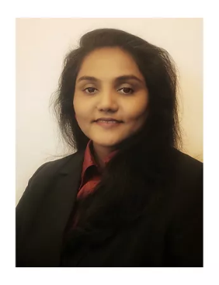
Teena Chrishanthini is a dedicated Soft skills/ Life skills trainer, passionate motivational speaker, an incredible professional development trainer and life coach. She strongly believes in inspiring, training and transforming people for leveraging one’s potential and strengthening skills required to emerge into happy, successful and better human beings.
Teena having a demonstrated history of working in HR, Education, Service and IT industry in India, UAE and South Africa and having counseled thousands of people of all categories, facilitate people to improve their lifestyle, immerge into highly efficient leaders and be self-motivated to fulfill life’s purpose.
Teena has a strong professional educational background with Bachelors in Computer Application, Masters in Information Technology and Masters in Human Resource, making her a most excellent personality to impart and perk up one’s knowledge, skills and attitude.
She is a highly dedicated and energetic trainer who has conducted various soft skills/ life skills trainings like effective communication training, self-development, values and attitudes, interview skills, workplace effectiveness etc., to benefit individuals, educational institutions and companies.
She as an exceptional story teller and good communicator, aid her render interesting and effective, seminars and workshops to all the individuals and participants.
Teena has been a continuous learner who has attended various workshops, leadership summits and pursues various courses like Neuro Linguistic Programming, Emotional Intelligence, Design thinking and certification in counseling to give the best in whatever she does. She also holds Masters Diploma in Training and Development in Indian Academy of Training and Development which is a professional and intensive training course which has polished her to be well-trained trainer to provide exceptional training to the attendees.
Teena’s mission is to transform lives by transforming oneself and transforming others, being a spark.

